# 7-july-2021

Task

# What is RDBMS?

**RDBMS** stands for **Relational DataBase Management Systems**. It is basically a program that allows us to create, delete, and update a relational database. **It is a database system that stores and retrieves data in a tabular format organized in the form of rows and columns.** It is a smaller subset of DBMS which was designed by E.F Codd in the 1970s. The major DBMS like SQL, My-SQL, ORACLE is based on the principles of relational DBMS.

 It has the capability to handle larger magnitudes of data and simulate queries easily.

Relational Database Management Systems maintains data integrity by simulating the following features:

* **Entity Integrity:** No two records of the database table can be completely duplicate.
* **Referential Integrity:** Only the rows of those tables can be deleted which are not used by other tables. Otherwise, it may lead to data inconsistency.
* **User-defined Integrity:** Rules defined by the users based on confidentiality and access.
* **Domain integrity:**The columns of the database tables are enclosed within some structured limits, based on default values, type of data or ranges.

**Characteristics**

* Data must be stored in tabular form in DB file, that is it should be organized in the form of rows and columns.
* Each row of table is called record/tuple . Number of such records is known as the cardinality of the table
* Each column of the table is called an attribute/field. Number of such columns is called the arity of the table.
* Number two records of the DB table can be same. Data duplicity is therefore avoided by using a candidate key. Candidate Key is a minimum set of attributes required to identify the set of records uniquely.
* Tables are related to each other with the help for foreign keys.
* Database tables also allow NULL values, that is if the values of any of the element of the table are not filled or are missing, it becomes a NULL value, which is not equivalent to zero.

**Advantages**

* Easy to manage: Each table can be independently manipulated without affecting others.
* Security: It is more secure consisting of multiple levels of security. Access of data shared can be limited.
* Flexible: Updation of data can be done at a single point without making amendments at multiple files.
* Users: RDBMS supports client-side architecture storing multiple users together.
* Data fetching is faster because of relational architecture.
* Data redundancy or duplicity is avoided due to keys, indexes, and normalization principles.
* Data redundancy or duplicity is avoided due to keys, indexes, and normalization principles.

Disadvantages

* High Cost and Extensive Hardware and Software Support: Huge costs and setups are required to make these systems functional.
* Scalability: In case of addition of more data, servers along with additional power, and memory are required.

#### Difference between DBMS and RDBMS

|  |  |
| --- | --- |
| 1. It stores data as a file | 1. It stores data in tabular form which consist of rows and columns |
| 1. Data Redundacy is present in DBMS | 1. RDBMS uses normalization to remove the data redundancy. |
| 1. In DBMS as data redundancy is there so it is difficult to modify the data at all the locations. If we make changes at one location and forget to make the changes at other places then there will be two different values for the same data. | 1. in RDBMS there is negligible data redundancy so it is easy to make the changes. We just make the changes in one place and our work is done. |
| 1. In DBMS the data is stored such that there is no relationship between data | 1. RDBMS the data is stored in the form of tables which are related to each other with the help of foreign keys |

# Normalization:

* Normalization is the process of organizing the data in the database.
* Normalization is used to minimize the redundancy from a relation or set of relations. It is also used to eliminate the undesirable characteristics like Insertion, Update and Deletion Anomalies.
* Normalization divides the larger table into the smaller table and links them using relationship.
* The normal form is used to reduce redundancy from the database table.

why is this required? without Normalization in SQL, we may face many issues such as:

1. **Insertion anomaly**: It occurs when we cannot insert data to the table without the presence of another attribute
2. **Update anomaly**: It is a data inconsistency that results from data redundancy and a partial update of data.
3. **Deletion Anomaly**: It occurs when certain attributes are lost because of the deletion of other attributes.

## Types of Normal Forms:

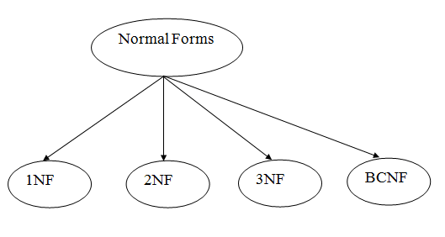

### **1st Normal Form (1NF)**

* A relation will be 1NF if it contains an atomic value.
* It states that an attribute of a table cannot hold multiple values. It must hold only single-valued attribute.
* First normal form disallows the multi-valued attribute, composite attribute, and their combinations.

In this Normal Form, we tackle the problem of atomicity. Here atomicity means values in the table should not be further divided. In simple terms, a single cell cannot hold multiple values. If a table contains a composite or multi-valued attribute, it violates the First Normal Form.

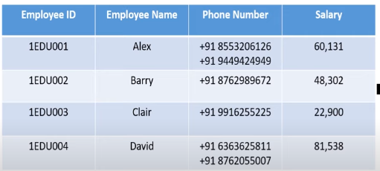

In the above table, we can clearly see that the Phone Number column has two values. Thus it violated the 1st NF. Now if we apply the 1st NF to the above table we get the below table as the result.

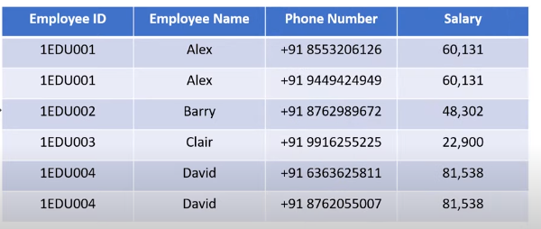

By this, we have achieved atomicity and also each and every column have unique values.

## **2nd Normal Form (2NF):**

The first condition in the 2nd NF is that the table has to be in 1st NF. The table also should not contain partial dependency. Here partial dependency means the proper subset of candidate key determines a non-prime attribute. To understand in a better way lets look at the below example.

Consider the table

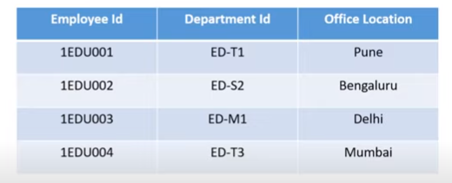

This table has a composite [primary key](https://www.edureka.co/blog/primary-key-in-sql/) **Emplyoee ID**, **Department ID**. The non-key attribute is **Office Location**. In this case, **Office Location** only depends on **Department ID**, which is only part of the primary key. Therefore, this table does not satisfy the second Normal Form.

To bring this table to Second Normal Form, we need to break the table into two parts. Which will give us the below tables:

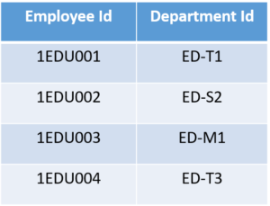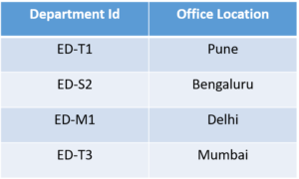

As you can see we have removed the partial functional dependency that we initially had. Now, in the table, the column **Office Location** is fully dependent on the primary key of that table, which is **Department ID**.

Now that we have learnt 1st and 2nd normal forms lets head to the next part of this Normalization in SQL article.

## **3rd Normal Form (3NF)**

The same rule applies as before i.e, the table has to be in 2NF before proceeding to 3NF. The other condition is there should be no transitive dependency for non-prime attributes. That means non-prime attributes (which doesn’t form a candidate key) should not be dependent on other non-prime attributes in a given table. So a transitive dependency is a functional dependency in which X → Z (X determines Z) indirectly, by virtue of X → Y and Y → Z (where it is not the case that Y → X)

Let’s understand this more clearly with the help of an example:

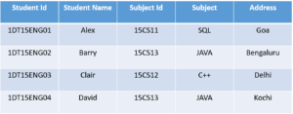

In the above table, **Student ID** determines **Subject ID**, and **Subject ID** determines **Subject**. Therefore, **Student ID** determines **Subject** via **Subject ID.**This implies that we have a transitive functional dependency, and this structure does not satisfy the third normal form.

Now in order to achieve third normal form, we need to divide the table as shown below:

# What is Normalization in SQL and what are its types?

Data in [Database](https://www.edureka.co/blog/what-is-sql/) is stored in terms of enormous quantity. Retrieving certain data will be a tedious task if the data is not organized correctly. With the help of Normalization, we can organize this data and also reduce the redundant data. Through the medium of this article, I will give you a complete insight of  Normalization in SQL.

The following topics will be covered in this article:

* [What is Normalization in a Database?](https://www.edureka.co/blog/normalization-in-sql/#normalization)
* [What are 1NF, 2NF, 3NF and BCNF Normal Forms?](https://www.edureka.co/blog/normalization-in-sql/#1stNF)
  + [1st Normal Form (1NF)](https://www.edureka.co/blog/normalization-in-sql/#1stNF)
  + [2nd Normal Form (2NF)](https://www.edureka.co/blog/normalization-in-sql/#2ndNF)
  + [3rd Normal Form (3NF)](https://www.edureka.co/blog/normalization-in-sql/#3rdNF)
  + [Boyce-Codd Normal Form(BCNF)](https://www.edureka.co/blog/normalization-in-sql/#BCNF)

**What is Normalization in a Database?**

It is the processes of reducing the redundancy of data in the table and also improving the data integrity. So why is this required? without [Normalization](https://en.wikipedia.org/wiki/Database_normalization) in SQL, we may face many issues such as

1. ***Insertion anomaly***: It occurs when we cannot insert data to the table without the presence of another attribute
2. ***Update anomaly***:  It is a data inconsistency that results from data redundancy and a partial update of data.
3. ***Deletion Anomaly***: It occurs when certain attributes are lost because of the deletion of other attributes.

In brief, normalization is a way of organizing the data in the database. Normalization entails organizing the columns and tables of a database to ensure that their dependencies are properly enforced by [database](https://www.edureka.co/blog/what-is-mysql/) integrity constraints.

It usually divides a large table into smaller ones, so it is more efficient. In 1970 the First Normal Form was defined by Edgar F Codd and eventually, other Normal Forms were defined.

One question that arises in between is, what does [SQL](https://www.edureka.co/blog/sql-basics/) have to do with Normalization. Well [SQL](https://www.edureka.co/blog/what-is-sql/) is the language that is used to interact with the database. To initiate any interaction the data present in the database has to be of Normalized Form. Else we cannot proceed further as it results in anomalies.

Normalization in SQL will enhance the distribution of data. Now let’s understand each and every Normal Form with examples.

### NF - Normalization in SQL - Edureka

### **1st Normal Form (1NF)**

In this Normal Form, we tackle the problem of atomicity. Here atomicity means values in the table should not be further divided. In simple terms, a single cell cannot hold multiple values. If a table contains a composite or multi-valued attribute, it violates the First Normal Form.

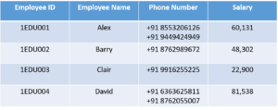

In the above table, we can clearly see that the Phone Number column has two values. Thus it violated the 1st NF. Now if we apply the 1st NF to the above table we get the below table as the result.

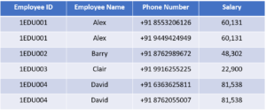

By this, we have achieved atomicity and also each and every column have unique values.

### **2nd Normal Form (2NF)**

The first condition in the 2nd NF is that the table has to be in 1st NF. The table also should not contain partial dependency. Here partial dependency means the proper subset of candidate key determines a non-prime attribute. To understand in a better way lets look at the below example.

Consider the table

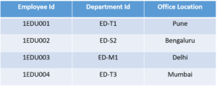

This table has a composite [primary key](https://www.edureka.co/blog/primary-key-in-sql/) **Emplyoee ID**, **Department ID**. The non-key attribute is **Office Location**. In this case, **Office Location** only depends on **Department ID**, which is only part of the primary key. Therefore, this table does not satisfy the second Normal Form.

To bring this table to Second Normal Form, we need to break the table into two parts. Which will give us the below tables:



As you can see we have removed the partial functional dependency that we initially had. Now, in the table, the column **Office Location** is fully dependent on the primary key of that table, which is **Department ID**.

Now that we have learnt 1st and 2nd normal forms lets head to the next part of this Normalization in SQL article.

### **3rd Normal Form (3NF)**

The same rule applies as before i.e, the table has to be in 2NF before proceeding to 3NF. The other condition is there should be no transitive dependency for non-prime attributes. That means non-prime attributes (which doesn’t form a candidate key) should not be dependent on other non-prime attributes in a given table. So a transitive dependency is a functional dependency in which X → Z (X determines Z) indirectly, by virtue of X → Y and Y → Z (where it is not the case that Y → X)

Let’s understand this more clearly with the help of an example:



In the above table, **Student ID** determines **Subject ID**, and **Subject ID** determines **Subject**. Therefore, **Student ID** determines **Subject** via **Subject ID.**This implies that we have a transitive functional dependency, and this structure does not satisfy the third normal form.

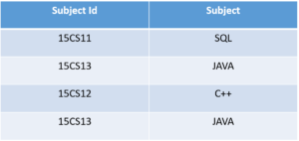Now in order to achieve third normal form, we need to divide the table as shown

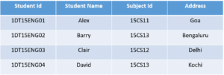 

As you can see from the above tables all the non-key attributes are now fully functional dependent only on the primary key. In the first table, columns **Student Name, Subject ID** and **Address** are only dependent on **Student ID**. In the second table, **Subject** is only dependent on **Subject ID**.

# **ACID properties of transactions**

In the context of transaction processing, the acronym ACID refers to the four key properties of a transaction: atomicity, consistency, isolation, and durability.

**Atomicity**

All changes to data are performed as if they are a single operation. That is, all the changes are performed, or none of them are.

For example, in an application that transfers funds from one account to another, the atomicity property ensures that, if a debit is made successfully from one account, the corresponding credit is made to the other account.

**Consistency**

Data is in a consistent state when a transaction starts and when it ends.

For example, in an application that transfers funds from one account to another, the consistency property ensures that the total value of funds in both the accounts is the same at the start and end of each transaction.

**Isolation**

The intermediate state of a transaction is invisible to other transactions. As a result, transactions that run concurrently appear to be serialized.

For example, in an application that transfers funds from one account to another, the isolation property ensures that another transaction sees the transferred funds in one account or the other, but not in both, nor in neither.

**Durability**

After a transaction successfully completes, changes to data persist and are not undone, even in the event of a system failure.

For example, in an application that transfers funds from one account to another, the durability property ensures that the changes made to each account will not be reversed.

8-july-2021 10:35AM

Why Database?

SQL is a Language.

MYSQL, ORACLE, POSTGRESQL, SQL SERVER are Providers or propritory software

SQL is saying these are the language fundamentals we need to use for every database.

SQL (interface)

* 1. Oracle
  2. MySql
  3. Db2

SQL is Case Insensitive(SELECT, select, SeLEct)

SQL sub-languages

1. DDL(Data Definition Language)
   * 1. Create
     2. Alter
     3. Drop
     4. Truncate
2. DML(Data Manipulation Language)
   1. Insert
   2. Update
   3. delete
3. DQL(Data Query Language)
   1. Select
4. TCL(Transaction Control Language)
5. Commit
6. Rollback
7. Savepoint (save your transaction if any failure happen we can get back our transaction from where it left out eg:game )
8. DCL(Data Control Language)

You want to give access to user or guest we can use below commands

1. Grant
2. Revoke

**Clauses:**

WHERE - clause directly apply on that expression/query

GROUP BY - You can categorized anything based on city.

HAVING – If you want further filteration to the GROUPBY output

ORDER BY – Order by column1,column2 in either asc(default)/desc.

**Aggregate Functions(across multiple rows):**

Aggregate functions will give single result for a group or cateogory.

Aggregate function can be used in **SELECT or in HAVING only**

1. **Sum()**
2. **Avg()**
3. **Min()**
4. **Max()**
5. **Count()**

**Scalar or Non-aggregate function(PER ROW):**

* + String function
  + Date/time function
  + Math function
  + Miscellaneous functions

9-July-2021

10:30

Joins

12:15PM

PL/SQL tables will be in documents , graphs etc but not in tables like SQL. Its is un structured.

Programming language + SQL

(loops,conditions,methods,switch cases)+SQL

Contains storedproceducres

callcalculateSalary(){

}

Contains 2 blocks

1. Stored procedure(void type)
2. Functions(should must return value)

Create or replace

Procedure calsalary

AS

Name varchar(20);

End calslary;

-------------------------------------------------------------------

Create or replace function

Myfunc

12:23PM

JDBC: Java Database Connectivity/Connection:

* JDBC is a breach driver which provide connection between JAVA and SQL or PL/SQL.
* Takes data from java and translate it into a format which is understandable by sql and delivers it to the sql.
* Takes data from SQL and translate it into a format which is understandable by Java and delivers it to the Java.

Steps to connect to SQL using JDBC:

1. Load or Register Driver(i.e postgress driver) adding dependcies of postgres.
2. Open Connection (url,username,password)
3. Create Statement. There are 3 types of statements
4. Statement

* If there are 1000 statements it compiles 1000 times and 1000times it runs
* It is prone to SQL injection ex username = ‘drop table login’
* Ex : select username from where username = ‘tom’ and password = ‘jerry’;

1. PreparedStatement extends Statement

* Precompiles once and runs 1000 times and it recompile only and only when there is change in syntax of your query.
* Prepared statement uses query based parameters which are not prone to SQL injection.

1. CallableStatement extends PreparedStatements
   1. Specifically used for PL/SQL for calling stored procedures.
2. Execute Query
3. boolen execute() return type – DDL
4. ResultSet executeQuery() -It is a pointer points to the result of the select query(DQL).
5. executeUpdate() – we get output like 1row inserted/1 row deleted (DML). Output will be in int.

All the above a,b,c can execute any statement like select update alter, delete but if you are proper response u need to look for approper method() and to get approp result.

getInt(),getFloat() etc are overloaded methods.

1. Process Results : for storing the results of the query and stored into javaobject like list etc so that we can process it later. Once the resultSet is closed we loss the data so we use list or something to store it and later we can process it.
2. Clone the connection or Release the connection.

Interfaces here : Statement, Prepared Statement, Callable Statement, Result set and Connection

Classes : DriverManager is a class

Step1: load driver

Got to DBeaver> postgress>editconnection> Edit Driver Settings > copy Classname, URL Template and Default port.

Class.forName("org.postgresql.Driver");

Step2: Open connection

String url = "jdbc:postgresql://localhost:5432/postgres";

jdbc:postgresql://{host}[:{port}]/[{database}]

String user = "postgres";

String password = "12345";

connection = DriverManager.getConnection(url, user, password);

System.*out*.println("Connection Established");

A Connection is the session between java application and database. The Connection interface is a factory of Statement, PreparedStatement, and DatabaseMetaData i.e. object of Connection can be used to get the object of Statement and DatabaseMetaData.

Step 3 : Creating Statement

Statement statement = connection.createStatement();

String sql = "select productid,name,rating,cost,available from product_schema.product order by rating";

Step 4 : execute Query

ResultSet resultSet = statement.executeQuery(sql);

System.out.println("Query Executed Successfully");

Step 5 : Process Result

//result is pointing to result---it will be like an array we use .next() read and increment

//if there is record need to be read it will say true and move ptr to that particular record

//result set will be pointing to before first and checks is there any record need to be read "Yes" then next()

// will also see is there any record need to be read "Yes" then print it out

while(resultSet.next()) {

System.out.print("Product Id "+ resultSet.getInt("productid")+" ");

System.out.print("Product Name "+resultSet.getString("name")+" ");

System.out.print("Product Rating "+ resultSet.getFloat("rating")+" ");

System.out.print("Product Cost "+ resultSet.getFloat("cost")+" ");

System.out.println("Product Available “+ resultSet.getBoolean("Available"));}

Step6: Close the connection

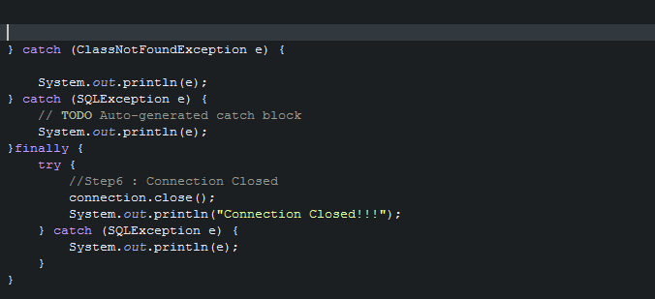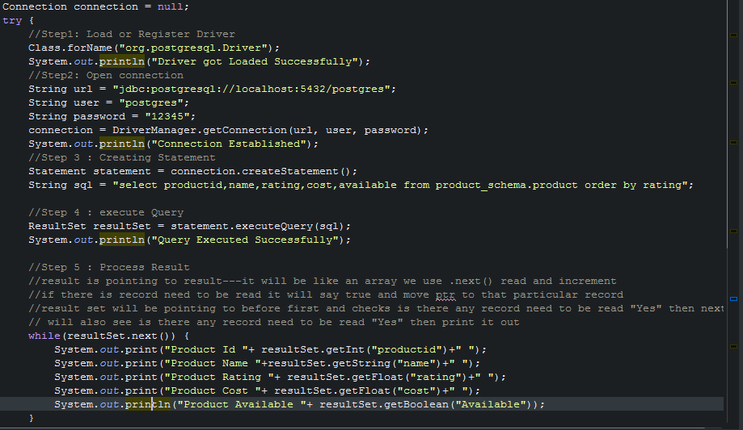Connection.close();

12-July-2021

11:05AM

Presentation layer : mouth of your project in casual. (psvm)

ProductService

Service layer : all the logic calculation everything is valid or not.

ProductDAO : Data Access object

I)Database layer : who will take care of db operatios, handshakes etc.

Product class which are commonly used by all the 3 layers.

First creational pattern- Singleton Design pattern

There will be only once instance of the object(all the common code will be put here. Like we opens connection once not like eveytime opening and closing)

Step1: create singleton

Step2: - make your constructor private so that nobody can access it.

Step3: Have a static method which checks is the instance is always available if yes? It will return that instance else it will create a new instance and revert to it. Eg: do I have this object already then return it else create a new one and return it and also checking there should be only object remains specially for this class.

Statement.RETURN_GENERATED_KEYS is only for autogeneting column only!!!!

Step1: create maven project add the postgres depen

Step2: create product class with name Product.java and package name should be com.app.model in src/main/java

Step3 : how column names are there in the table you need to maintain here same.

Private int product id and so onn.. then generate constructors with fields, getters and setters also string.

Step4 : in the same src/main/java create the interface where all the req will go

Interface ProductDAO and package com.app.dao

All the customer requirements will go here like create a product

Step 4 : now go and create implementation class

Package : com.app.dao.impl

Classs : ProductDAOImpl which implements ProjectDAO interface

Step5: Creating singleton class to put the common code for connection

Package : com.app.dbutil

Class : PostgresConnection

Creating static class Connection

private static Connection connection; // its an sql class and its object

private PostgresConnection(){} //constr why private? Bcoz every1 wil create object of it then what is the use of creating common separate class for common code.

creating-> public static Connection getConnection() throws ClassNotFoundException{ }

result set is for reading, with the resultset only im poiting to that key and which is being genr and im getting that key and setting it to product object.

Step 7 :

Com.app.exception

Class : BusinessException

Extending Exception class //bcoz its checked exception

Source>create consstr with super class and only tick excpetion and string

Make final as string.

Step 8 : package = com.app.main

Class = Main.java

Product product = new Product(“name”,”rating”,”cost”,”available”,”manufacturerid”);

ProductDAO productDao = new ProductDAOImpl();

product=productDAO.createProduct(product);

getProductId()

whenever your are searching always create a Product class and object project also initially keep it as null

Product product = null;

Then say return product;

* Where ever you are expecting data create it there I mean new object
* When insert is happening ,Whenever you are expecting data from a presentation layer that is where u r creating the object.
* When search is happng im expecting data from the persistant layer, im not creating object,
* Ex: Product product = null;
* Means only if I finding an product then only im creating the poduct object
* Product = productDAO.getProductId();

**13-JULY-2021**

11:42Am

HTML

-hypertext markup language

- understood by all the browsers in the world

- no installation or no setup required all that you need a.html file and a browser

**14-july-2021(Week-3 Day-3)**

what is client-server architecture? who is client? who is server? what is web server and application server? Web server vs Application Server. What is http and https protocol? why http is called stateless protocol? different http methods and its uses. various http status codes(100-500).

JSP, SERVLETS, EJB CONTAINERS, APPACHE TOMCAT, HTML CSS JAVASCRIPT.

GET AND POST

PUT PACHE

HEAD

XML

J2SE, J2EE, JSE

jdbc:postgresql://localhost:5432/mydatabase?currentSchema=myschema

What is Client-Server?

11:15Am

Client/Browser/User/App : A client is a program that runs on a local machine requesting service from the server.

Client Side Scripting Languages : HTML,CSS,JAVASCRIPT and its Libraries like Angular,React etc…

Server : A server is software designed to process requests and deliver responses to another computer over the internet.

A Client and a Server establish a connection according to a set of rules called a protocol. There are quite a few protocols for different purposes, but one of the most popular is the **HTTP protocol**. Once the connection is established, the Client sends **HTTP Requests** to the server in the form of XML or JSON, which both entities (Client and Server) understand. After parsing the request, the Server responds with appropriate data by sending back an **HTTP Response**.

Serverside scripting tool: Servlet,JSP,EJB here we are using Java for writing the response.

Database : Server interact with the database using the providers like JDBC /HIBERNATE/JPA

Other providers are IBATIS, LINQ

### **Types of Client-Server Architecture**

**2 tier architecture** - The user interface stored at the client machine and the database stored on the server. If Business Logic & Data Logic collected at a client-side, then it is known as a fat client thin server architecture. If Business Logic & Data Logic handled on the server, then it is known as a thin client fat server architecture. 2 tier architecture has some limitations in performance, security, and portability.

**3 tier architecture** - Three-tier architecture has a middleware between the user interface and database. The 3 tiers are named the presentation tier, application tier, and data tier. The presentation tier is the front end layer and consists of the user interface. The application tier contains the functional business logic which drives an application’s core capabilities. The data tier consists of a database system and the data access layer.

**n-tier architecture** - In n-tier architecture, there are multiple Business Logic & Data Logic layers. It increases the flexibility and reusability of applications but can be difficult to implement.

Client sends a request to server, server receive the request process it and sends it back to the client.

Here request consist of **request parameters**(in case of login, userid and pw are the request parameters), request type= either he wants to CRUD, search or process anything etc. and also it pases meta info in the sense what type of data im sending, is it a .xml data? or .json data? etc.

Server will process this request based on the reqParameters, requestType and Meta info etc, if required it also interacts with the DB and generate a reponse. Reponse also having data or the error msg like 404 error, or anyother metainfo message provided to the client based on the request by the server

Here we are using HTML CSS for designing our client pages and using JavaScript to make a request to the server and in the server side we will be having Servlet who reads the incoming request and it will process the request and generate the response.

We have HTTP METHODS for making calls for the resources in the server.

POST – Creating a resource in the backend like creating an employee

PUT/PATCH – Update update emp details

GET – Read/Search

Delete – Delete

Take example of employee here.

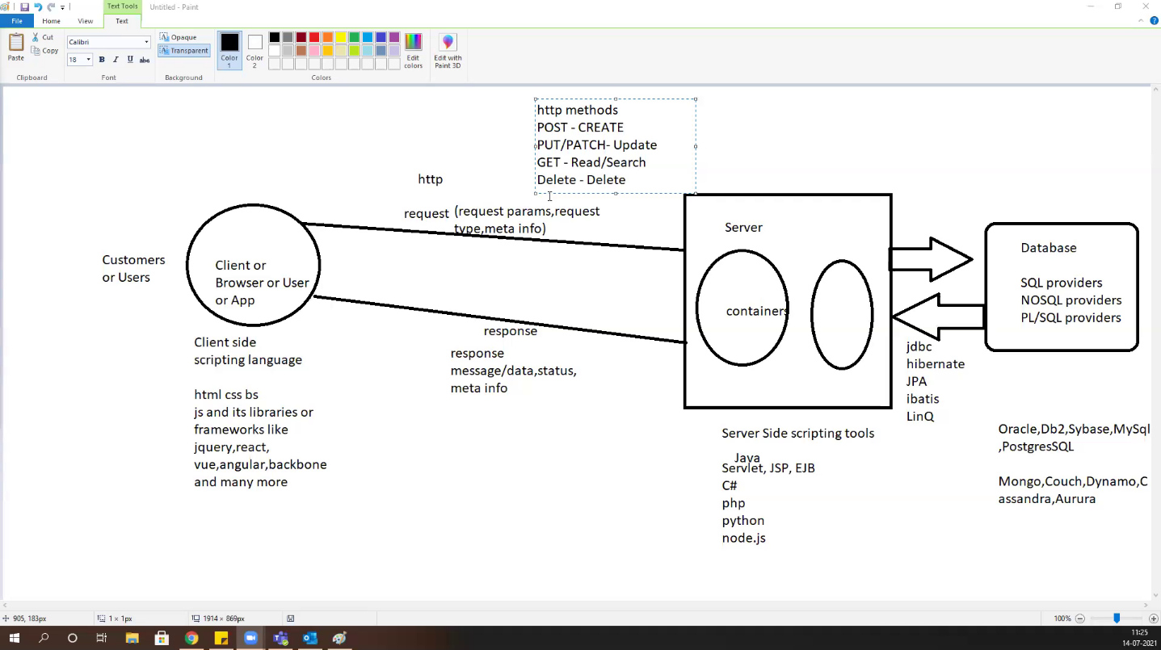

**HTTP Status codes : are issued by a server in response to a client's request made to the server.**

* *1xx informational response* – the request was received, continuing process
* *2xx successful* – the request was successfully received, understood, and accepted
* *3xx redirection* – further action needs to be taken in order to complete the request
* *4xx client error* – the request contains bad syntax or cannot be fulfilled
* *5xx server error* – the server failed to fulfil an apparently valid request

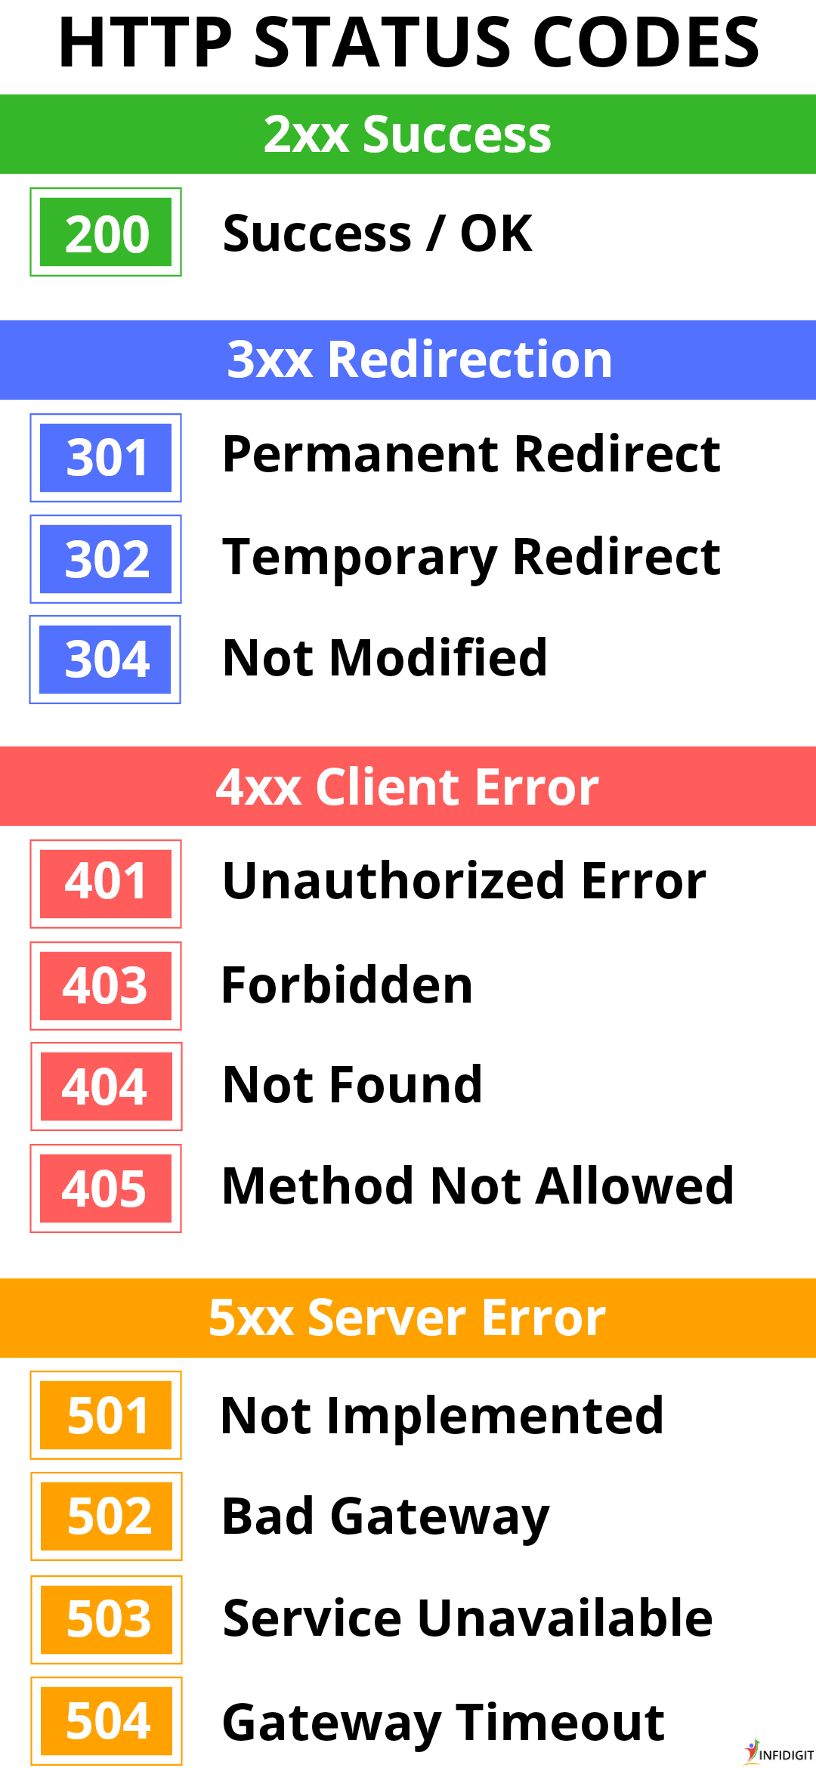

**HTTPS:** It is lightweight,fastest and stateless(don’t remember data where it goes. When it goes to next page it forgets where it there previously) protocol.

## **http vs https**

| http | https |
| --- | --- |
| Transfers data in hypertext (structured text) format | Transfers data in encrypted format |
| Uses port 80 by default | Uses port 443 by default |
| Not secure | Secured using SSL technology |
| Starts with http:// | Starts with https:// |

**Advantages of HTTPS:**

* **Secure Communication:** https makes a secure connection by establishing an encrypted link between the browser and the server or any two systems.
* **Data Integrity:** https provides data integrity by encrypting the data and so, even if hackers manage to trap the data, they cannot read or modify it.
* **Privacy and Security:** https protects the privacy and security of website users by preventing hackers to passively listen to communication between the browser and the server.
* **Faster Performance:** https increases the speed of data transfer compared to http by encrypting and reducing the size of the data.

You might have noticed that web addresses often start with https://. The HTTPS is the secure version of the HyperText Transfer Protocol guarantees that only the client and the server can understand the info that is send from one side to the other.

You can think HTTPS is a language that one computer uses to ask another computer for a document sharing.

Using GET can makes the person Intercept on our convo easily.

Let say you login to facebook.com well first thing you do is you make a POST request, that is a POST to facebook’s login page that has some data attached to it. It has your email and password that goes to the facebook’s server. Facebook’s server figures out that okay, you’re David. It sends a web page back to your browser that says, success! Logged in as David. But along with that web page, it also attaches a little bit of invisible cookie data that your browser sees and knows to save.

And it’s really important because it’s really the only way that a website can remember who you are. All that cookie data is an ID card for facebook. It’s a number that identifies you as David. And your web browser holds on to that number and the next time you refresh facebook, the next time you go to facebook.com, your web browser knows automatically attach that ID number with that request that it sends over to facebook’s servers, So now facebook servers sees the request coming from your browser, sees the ID number and knows okay this is request from DAVID.

**Java Enterprises Edition(JEE) :**  is designed to help developers to create large-scale, multi tired, scalable, reliable and secure network applications.

Lates Version of JEE is JavaEE7

Static page whose content may not change eg. Style.css, .html, .js .jpg

Dynamic page : whose content changes frequently eg. Userlogin page home page etc.

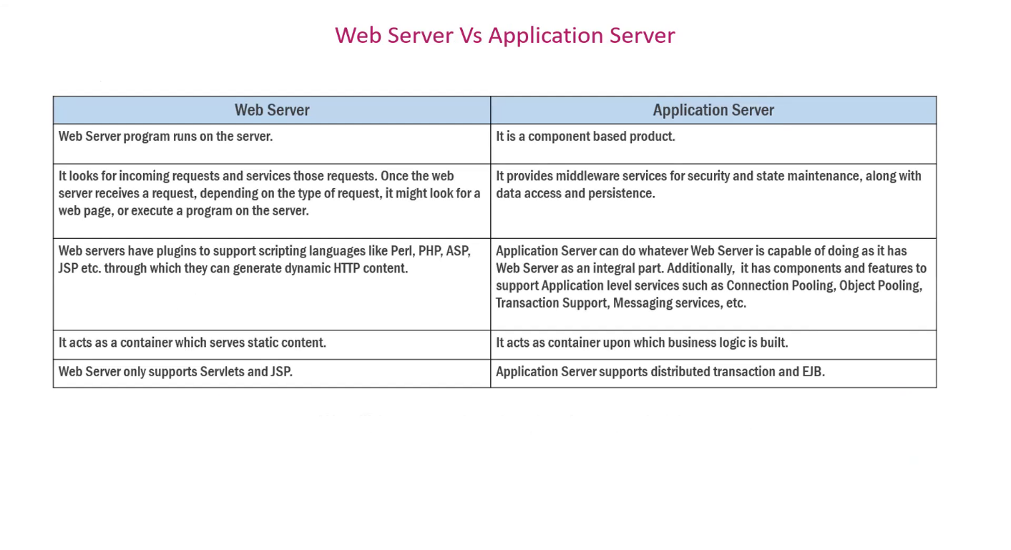

**CLIENT REQUEST TYPES**

**1.**GET Request :

* Used to GET the resource
* It can send unlimited data
* It is not secure, can be bookmarked and , the data is visible in URL
* It is default method for the https. All the urls in the world are GET by default

**2.**POST Request:

* It Is used to process data, save data, change data etc.
* It is secure and cannot be bookmarked
* No limit on data; sent as “payload” and not appended in URL

**3.**PUT is all about updating, it will be update completely.

**4.**Patch is use for complete update.

**5**.Delete request is used to delete a document of the target resource given by URL

**6**.OPTION request return the HTTP method which is supported by the server.

**7.**Head request is used for testing hypertext links for accessibility, validity and recent modification. It generally asks for META info. It is kinda similar to GET but here it asks for reponse without the reponse body.

All the html,css, js and other client side files will be in Web Content folder.

New -> dynamic web project-> next-> generate web.xml -> finish

When ever you are making changes always restart your server.

Tomcat is a Web server Hosting my application server, I gave my app to tomcat server what TomCat is doing is, first it goes into **web.xml file**  and understands is your welcome file is index.html and runs it. If tries to run difff file then it will give 404 Error.

Whoever missed generating web.xml file right clik on your project -> JEE and generate deployment descriptor.

**19-july-2021 2:54PM (Week4- day1)**

**Servlets(JEE)**

* Servlets is a server side scripting tool
* A servlet is a small Java program that runs within a Web server. Servlets receive and respond to requests from Web clients, usually across HTTP, the HyperText Transfer Protocol.
* Capable of handling incoming request and generate appropriate response.
* Written using java, we still write all the code in .java file itself. And handle all the repsonses using https request.
* Servlets handle the request and responses in multithreaded way which makes it lighter than traditional CGI(Common-Gateway-Interface).

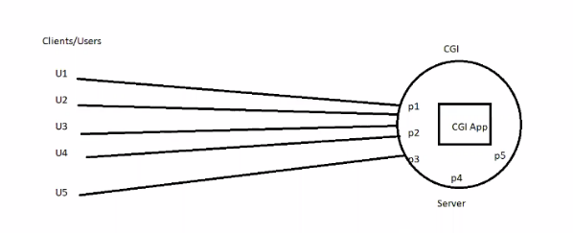What CGI will do is, if there are 5 clients are sends the request it makes separate process for each user which is heavy for the server. If there are n request coming if opens for n times, this may cause memory overflow. And need more hardware support if crowd increases.

To over come above problem we come up with servlet concept which handles the problem in a multithreaded way and also run by itself. What Servlet do is it will create and run a process which then each process consist of number of threads that shares same memory with the process and capable of handling multiple request parallery from the users, by this the, Process will execute only for the one time and internal threads serves the user requests. This approach helps to decrease or minimize the load on the CPU and work efficiently.

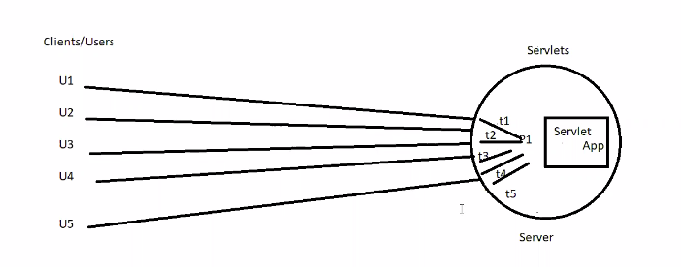

**Servlet’s Run on Life Cycle:**

1. void init(ServletConfig)

* This is the first phase of Servlet life cycle where the object of the Servlet Class is created when the request comes in and its been put in actively in the server to handle all the requests coming in.
* ServletConfig is a interface where we pass any custom configuration related to servlet.
* This LifeCycle stage will be executed only and only once.

1. Void service(ServletRequest, ServletResponse)

* This is the 2nd stage of lifecycle of servlet where we write the code of what exactly this servlet should do, you write the logic of handling incoming request and you will generate appropriate responses here, this lifecycle will be executed for number of requests once.
* **ServletRequest** is where the request objects or data come to the application which is input to servlet/service layer of servlet.
* **ServletResponse** is where when if servlet or service wants communicate back to the client.

1. void destroy()

* When there is no active request/thread on the particular Servlet, the servlet will be taken off from the main memory, that’s when the destroy() is invoked.
* This stage of lifecycle will be executed only and only once.

Tomcat(is a web server) has two containers:

1. Servlet Container (all life cycle will be executed)
2. JSP container(html,css)

What ever libraies we required to run app its there in the tomcat (servlet-api.jar), we don’t need JDK anymore.

Other than Tomcat we have Glassfish, IBM WebLogic, Oracle WebSphere, JBOSS, Jetty etc provides Containers.

* Utilize web.xml and understand deployment and also called as deployment descripter.
* One tomcat can run multiple application in it.
* Web.xml is a source of communication between server and the application html file.

**Web.xml file** is popularly known as configuration file or deployed descriptor for any JEE apps, All the deployment and configuration details which will be used by the web server will be given here and the web server utilized this file for all configuration details purpose.

Containers means where life cycle of Servlet is executed.

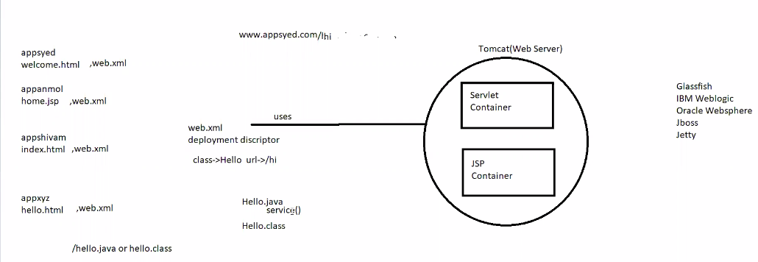

Javax.servlet.Servlet(Interface) : is a root interface for all the servlets. This is where it consist of life cycle methods like init() service() and destroy().

1.Javax.servlet.GenericServlet(AC) : which is an Abstract class and it is generic to any protocol inclusive to http.

In GenericServlet we will get void service(ServletRequest, ServletReponse) method

All init, service and destroy will be used by above hierarchy.

2.Javax.servlet.HttpServlet(AC) : It is a child of GenericServlet() and it gets all the properties of GenericServlet that means it also have void Service() method, Additionally HttpsServlet() provides specific methods to handle the specific request of Http methods like GET,PUT,POST,DELETE etc.

For Handling specific request we have specific HTTP methods which is going to handle the incoming request.

* For Reading - doGet(HttpServletRequest,HttpServletResponse)
* For Creation – void doPost(HttpServletRequest,HttpServletResponse)
* For Updation -doPut(HttpServletRequest,HttpServletResponse)/doPatch(HttpServletRequest,HttpServletResponse)
* For Deletion - doDelete(HttpServletRequest,HttpServletResponse) to delete the resource

As **void service(ServletRequest, ServletReponse)** is generic one, We don’t require all CRUD methods, just in case if **void service()** not there we require CRUD METHODS. If void **service()** method is in your servlet class then none of the CRUD will be called because **void service()** is of highest priority and also it is generic one. So, It can handle any type of request.

**There are only two types of Servlet :**

1. javax.servlet.GenericServlet(AC)
2. javax.servlet.http.HttpServlet(AC)

All two types of servlets are abstract classes, GenericServlet implements servlet.Servlet(I) interface where all the life cycle methods are available.

* Note that if the service method is there then none of the other methods are eligible to take the call, all requests(get,put,post or delete) will be routed to service only, and if service is not there that is when it will be routed to specific https methods for specific calls.
* NOTE : All URL/s in the world by default are of GET Request.
* From html form we can only make GET AND POST request.
* Using JavaScript on the front end we can make any http method call.

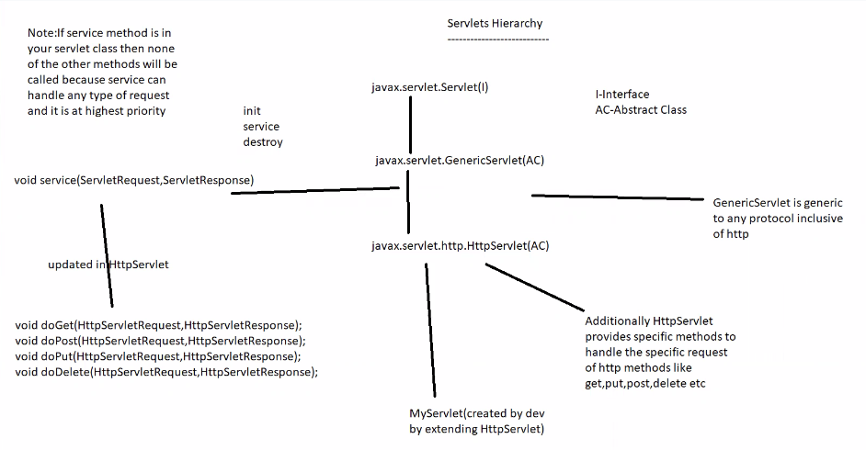

**Hello_servlet_app_demo program**

1)Setting the reponse object from service()

response.setContentType(“text/html”) : my reponses will be plain text or html

2)PrintWriter out = response.getWriter(); //it initilaze the **response object** which send reponse from the servlet to the browser or client

out.print(“Hello From Service Method of MyServlet()”)

* web.xml can be edited as per requirement
* we can give any number of names for the URL for a particular servlet
* if you are changing anything in the .java file or web.xml please restart tomcat server.
* HTML is only capable of doGet() and doPost(), JavaScript is capable of all the http methods.
* doGet() is universal for the html pages. Like if we don’t mentod any method=’’ by default it will be doGet().
* Whenever you are making changes in static pages like html we don’t have to restart Server.
* If we want anything from the client we use **request**  and if we want to tell anything to the client we use **response**
* We use request.getParameter(“fname”) for taking input from the client.
* Where ever user is selecting any input we should pass **value=’’** to input tag
* Where ever user is typing any input we should use **name=’’** attribute there
* Short hand to print an Array without for-each loop by using Arrays.toString(request.getParameterValues(“hobby”));

20-july- 12pm

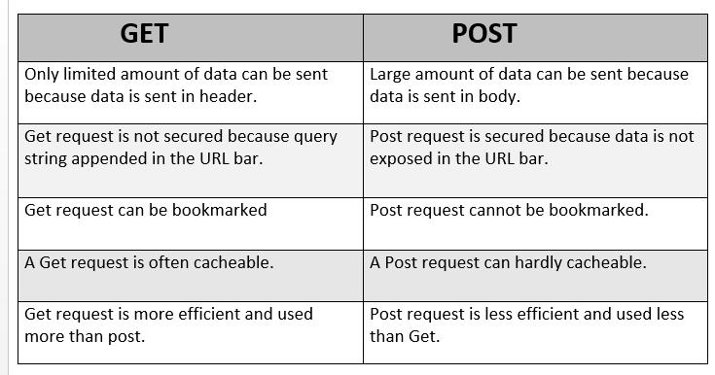

ServletConfig and ServletContext :

1)**ServletConfig :**

* It is a configuration based parameters which can be passed to specific servlet only.
* The Configuration params set using ServletConfig for a particular servlet which cannot be accessed by other Servlet.
* For eg: If Servlet1 has some config params which is been set using ServletConfig these params cannot be used in Servlet2, it is local to that Servlet only.
* To set config params in the web.xml file within servlet tag we can use <init-param></init-param> tag and give the param name and param value as a key value pair and you can access those params inside that particular Servlet Class.

ServletConfig config = getServletConfig();

Config.getInitParameter(“query1”) //here query1 is a key and will get the value

Config.getInitParameter(“query2”)

**2)ServletContext:**

* ServletContext is global to any servlets within this app, the context params set can be accessed by any Servlet throughout the entire application.
* We can set context params within web.xml file by using <context-param> tag within the <web-app> tag anywhere.

ServletContext context = getServletContext();

Context.getInitParameter(“driver”) //here driver is a key and it will give the value.

**servletConfig_and_ServletContext_demo program**

**RequestDispatcher API**

It provides below 2 methods

1)forward(request,response) - forward will forward the current request and response to the specific url mentioned within the application itself and will send the response of the forwarded page only and nothing else apart from it.

2)include(request,response) - include will include the response of current page and also the response of the page given in the url of include both together as one response will be sent to the browser.

In both the cases the URL wont change it will be the URL of that particular servlet where this code is written.

**Myservlet_login_page**

**response.sendRedirect("url") vs forward**

->sendRedirect changes the URL and creates new request, forward keeps existing request alive.

->forward only within the application, sendRedirect we can even navigate outside the application.

3:00PM

1) Hidden Form Fields

2. URL rewriting

3.Cookies : smallest part of info stored in client machine in a key value format both will be strings.

Adv : Light weight, everything maintains at client.

Disad : if client machine is public computer it is not safe

We can’t store objcts in cookies bcoz it is only n only stirng.

4.HttpSession :

Servlets provide 3 types of Scopes

1)ServletRequest - request scope – this is active until the current URL is not changed.

2)ServletContext – application scope – this is active until the entire application’s destroy is invoked

3)HttpSession – session scope – this is per session/per user/its b/w user login to logout.

Session will be unique to for every user.

5:05pm

Login app with session

21-july 10:30am

http/https methods

---------------------------

->GET(default) - Used for reading resource from server. Passes the data via the URL i.e it appends the data at the end of the url.

->POST - Used for creating a resource, it is secured comparable to get because it passes the data via the payload not the URL.

->PUT - used for updating the resource completely and it is idempotent in nature, passes the data via the payload.

Idempotent : I have a browser and a registration page , let say same user submitting the same data 100 times with same values. Here if I go with POST request, It will create 100 new resources where PUT will only start reacting when there is change in the values. If no change PUT won’t react. This is we called idempotent in nature.

->PATCH - used for partial update, sends data via the payload.

->DELETE - used for deleting the resource from backend, sends data via the URL similar to GET.

Complete Updation means object is getting modified completely

Partial Updation : Where as Partial Updation means only some fields in the object are getting modified.

Payload : browser storage we can say. That data can be send thru URL to the Server.

**hello_postman_demo : Demo to check out the http methods**

Postman is an API testing tool whatever Restful calls(doGet,doPost,doPut and doDelete) request we are making for all this things We don’t have to write Javascript to make a call. Before Writing JS for all of this calls we can Test those calls utilizing the tool just like POSTMAN. Apart from POSTMAN we have SAOPUI.

Which is used for API testing , this is part of testing only but technically we called as API Testing which means you are testing certain point in your application. Eg : like how the Get request is doing, what is the response of a Post request. We as Dev already aware what is expected request and expected response during testing thru this tool we can test in advance before writing JavaScript for all of this calls.

As you know HTML is limited to get and post only so it not a good idea to write JS for other calls like put and delete, so its better to use POSTMAN for testing those calls.

Before UI construction we are just making sure that everything is going absolutely perfect by testing the calls using POSTMAN.

JavaScript will be sending data either in .xml or .json format. As server won’t understand .json so we need a communicator like Jackson library

It will take JSON object and convert into java object POJO class we say

Eg : var employee = {“id” : 100, “name” : “suleman”, “designation” : “SDE”} ==> class Employee{Int id; String name; String designation;}

Jackson library will also do java object -> JSON object.

Our front-end which is written using html and javascript is different and backend which is written in java is different thing both has to communicate commonly b/w each other. So, what’s the common thing we can use? We can use .xml because we have XML Parsers over here on both the sides here java script will be having JS xml builders which build xml and send it to the backend, here java also have xml parsers which I can use to map it the java objects and when Im sending back this info as a response by converting into XML so that frontend can read that. This XML we are using for a common entity to do the handshake b/w two different application which is commonly known as web services.

Web Services: One application taking the services from another application with three things over an internet, over an network, over a protocol is what is called as Web Services. In this one application is acting as a service provider and another application is acting as a consumer and they are using http protocols primarily with all https methods to signal b/w each other so that what client is asking server will be able to understand that and process the reponses based on that. And they also need a common way so that they can communicate with each other. To communicate between them.

For example : we already have .xml in which is globally understandable or we can consider JS0N which is understood by al JS F/w so we don’t have to parsing or reading. We can directly convert HTML data whatever it is coming into json and makes those http calls and in the backend we are utilizing Jackson library to convert the JSON object into java object for the incoming request. We process and sends back the reponse by converting java object into back to the JSON object. That’s what makes the typical client server architecture with web services this type of web services where are effectively using http request with the redable XML readable JSON so such web services are called as RestFul WebServices here REST stands for : Representational state and Transfer based on http/https and communicate using redable XML or JSON. It is light weight and faster.

For this **Jackson library** , We are using **GSON** (Google’s Script object notion) which will be helpful in doing conversions like JSON to Java object and Vice Versa.

**Student_restful_api_demo**

22-july 11:51AM

DOM Events:

onclick

ondoubleclick

onsubmit

onload //what to do after page load

onfocus // after hovering

onblur

onmousehover

onmouseout

JSvalidation

Callbacks and promises in JavaScript

**22/7/2021 -> 2:20pm ajaxdemo.html**

Ajax – Asynchronous JS and XML is a callback style.

Has capability to get data from backend without refreshing the page.

This data reicve by JS once JS is recived and can put data on the html page for you.

XMLHTTPRequest() we can make http calls using XMLHTTP to make a call to backend api to make a request.

this keyword is local to its function in arrow function.

**fetchapidemo.html**

FetchApi is smiliar to AJAX but it is more of promise Style of writing the code which avoids all the boilerplate of code.

f